STATISTICS WITH R PROGRAMMING
Assessment Document
Chapter 2 — Simple Manipulations: Numbers and Vectors
Sections 2.5 to 2.7

Name – Sameer Ahmed G
Register Number - 192421154
Date – 07/10/2026

Introduction
This assessment covers Sections 2.5 to 2.7 of Chapter 2, Simple Manipulations: Numbers and Vectors. The objective is to understand how R represents missing values, handles character data, selects elements from vectors using index vectors, and modifies selected subsets. Each concept is accompanied by executable R code and a sample console result. The sample result is provided as a guide; the actual RStudio Console output should be captured and pasted into the corresponding screenshot area.

2.5 Missing Values
A missing value occurs when the value of an observation is not available or is not known. R represents a missing value using the special logical constant NA (Not Available). NA is different from an ordinary number, character string, or logical value. Many operations involving NA produce NA because the result cannot be determined from incomplete information.
For example, if x contains a missing value, arithmetic performed on that element normally also produces NA. Therefore, R provides the function is.na() to identify missing values.

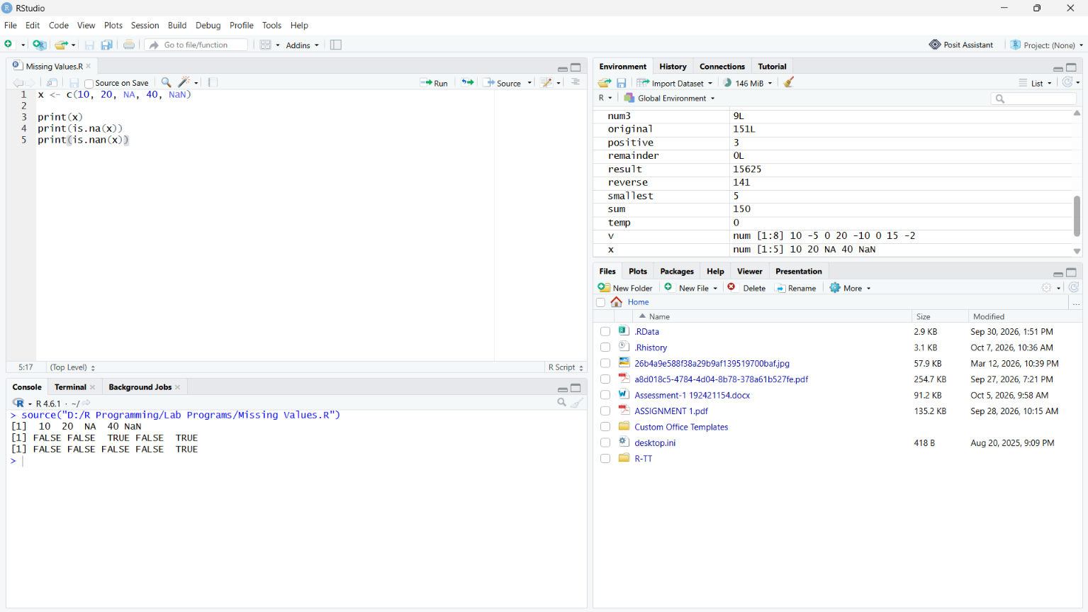

2.5.1 Creating a vector containing NA
Aim: To create and display a vector containing a missing value.
Explanation: NA can be inserted directly into a vector. The missing element occupies a position but does not contain a known value.

R Code:
x <- c(10, 20, NA, 40, 50)
x
Sample Console Output
[1] 10 20 NA 40 50
Key points: Use NA without quotation marks. "NA" is a character string and is not the same as the missing-value marker NA.

2.5.2 Identifying missing values using is.na()
Aim: To identify which elements of a vector are missing.
Explanation: is.na(x) returns a logical vector of the same length as x. TRUE indicates that the corresponding element is NA; FALSE indicates that it is not NA.

R Code:
x <- c(10, 20, NA, 40, NA)
is.na(x)
Sample Console Output
[1] FALSE FALSE TRUE FALSE TRUE

2.5.3 Selecting only non-missing values
Aim: To remove missing values from a vector using logical indexing.
Explanation: The expression !is.na(x) is TRUE for non-missing values. Using it inside square brackets selects only those elements.

R Code:
x <- c(10, 20, NA, 40, 50, NA)
y <- x[!is.na(x)]
y
Sample Console Output
[1] 10 20 40 50

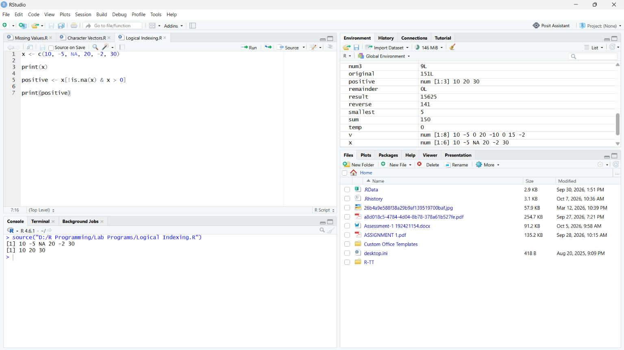

2.5.4 Selecting non-missing positive values
Aim: To select values that are both non-missing and positive.
Explanation: Two logical conditions can be combined with &. The expression !is.na(x) prevents missing values from being selected, while x > 0 selects positive values.

R Code:
x <- c(10, -5, NA, 20, -2, 30)
z <- (x + 1)[!is.na(x) & x > 0]
z
Sample Console Output
[1] 11 21 31

2.5.5 Replacing missing values
Aim: To replace all NA values in a vector with zero.
Explanation: An indexed expression can occur on the left side of an assignment. The positions satisfying is.na(x) are selected and replaced by 0.

R Code:
x <- c(10, NA, 30, NA, 50)
x[is.na(x)] <- 0
x
Sample Console Output
[1] 10 0 30 0 50

2.5.6 NaN — Not a Number
R also has a second kind of missing or undefined numerical result called NaN (Not a Number). It is commonly produced by undefined numerical operations such as 0/0 or Inf - Inf.

2.5.6.1 Producing NaN
Aim: To observe a NaN result produced by an undefined numerical operation.
Explanation: The operation 0/0 cannot be assigned a meaningful finite numerical result, so R returns NaN.

R Code:
a <- 0 / 0
a
Sample Console Output
[1] NaN

2.5.6.2 Distinguishing NA and NaN
Aim: To determine whether a value is NA or specifically NaN.
Explanation: is.na() returns TRUE for both NA and NaN. is.nan() returns TRUE only for NaN values.

R Code:
x <- c(NA, NaN, 10)
is.na(x)
is.nan(x)
Sample Console Output
[1] TRUE TRUE FALSE
[1] FALSE TRUE FALSE
Key points: Remember: is.na(NaN) is TRUE, but is.nan(NA) is FALSE.

2.6 Character Vectors
Character vectors store text values. They are frequently used for labels, names, categories, messages, and other textual information. Character strings can be enclosed in double quotes or single quotes.

2.6.1 Creating a character vector
Aim: To create and display a character vector.
Explanation: The c() function can concatenate character strings into a single character vector.

R Code:
names <- c("Sameer", "Rahul", "Priya", "Anu")
names
Sample Console Output
[1] "Sameer" "Rahul" "Priya" "Anu"

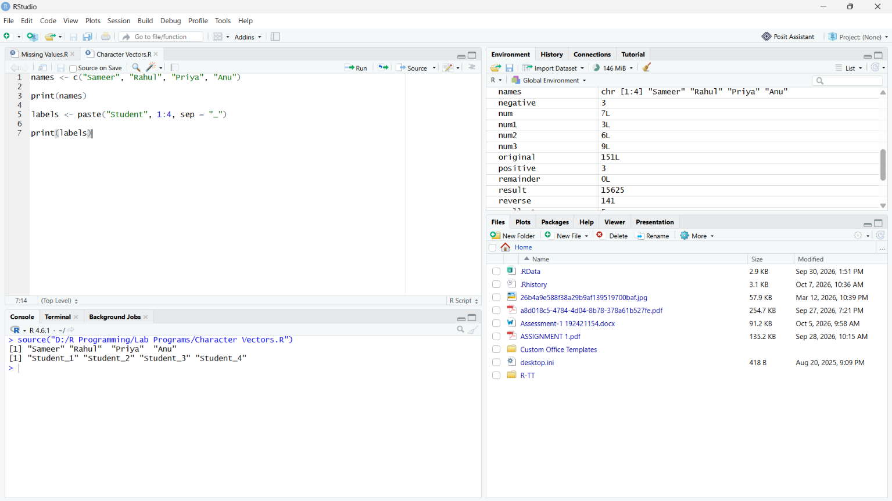

2.6.2 Character strings and escape sequences
Aim: To demonstrate newline, tab and quotation-mark escape sequences.
Explanation: R uses backslash escape sequences. Common examples are \n for a new line, \t for a tab, and \" for a double quote inside a double-quoted string.

R Code:
cat("Name:\tSameer\nCourse:\tStatistics with R\nMessage: \"Hello R\"")
Sample Console Output
Name: Sameer
Course: Statistics with R
Message: "Hello R"
Key points: Use cat() when you want escape sequences such as \n and \t to be interpreted visibly in the Console.

2.6.3 Combining character vectors using c()
Aim: To concatenate character vectors into one vector.
Explanation: The c() function combines its arguments in order. Character values are retained as character data.

R Code:
x <- c("R", "Python", "Java")
y <- c("C", "C++")
z <- c(x, y)
z
Sample Console Output
[1] "R" "Python" "Java" "C" "C++"

2.6.4 paste() with sep
Aim: To generate labels by combining character values and numbers.
Explanation: paste() combines its arguments into character strings. The sep argument specifies the separator placed between components. With sep = "", no separator is inserted.

R Code:
labs <- paste(c("X", "Y"), 1:10, sep = "")
labs
Sample Console Output
[1] "X1" "Y2" "X3" "Y4" "X5" "Y6" "X7" "Y8" "X9" "Y10"
Key points: R recycles the shorter vector when necessary. Here c("X", "Y") is recycled while matching the sequence 1:10.

2.6.5 paste() using a custom separator
Aim: To combine strings with a chosen separator.
Explanation: The sep argument controls exactly what is placed between the arguments.

R Code:
paste("Statistics", "with", "R", sep = "-")
Sample Console Output
[1] "Statistics-with-R"

2.7 Index Vectors: Selecting and Modifying Subsets
Indexing allows individual elements or subsets of a vector to be selected. In R, square brackets [ ] are used for indexing. An index can be logical, positive integer, negative integer, or a character vector when the object has names.

2.7.1 Logical index vectors
A logical index vector contains TRUE, FALSE, and possibly NA. TRUE positions are selected, while FALSE positions are omitted. A common application is filtering values using a condition.

2.7.1.1 Selecting non-missing values
Aim: To select all non-missing elements using a logical index vector.
Explanation: The logical vector !is.na(x) is used as an index. Elements corresponding to TRUE are selected.

R Code:
x <- c(10, NA, 20, NA, 30)
y <- x[!is.na(x)]
y
Sample Console Output
[1] 10 20 30

2.7.1.2 Filtering positive values
Aim: To select positive and non-missing values from a vector.
Explanation: Multiple logical conditions can be combined with & and used directly as an index.

R Code:
x <- c(10, -5, NA, 20, -2, 30)
z <- x[!is.na(x) & x > 0]
z
Sample Console Output
[1] 10 20 30

2.7.2 Positive integer index vectors
A positive integer index selects elements by their positions. The first element has position 1, the second has position 2, and so on. Indices can be repeated, and the order in the result follows the order of the index vector.
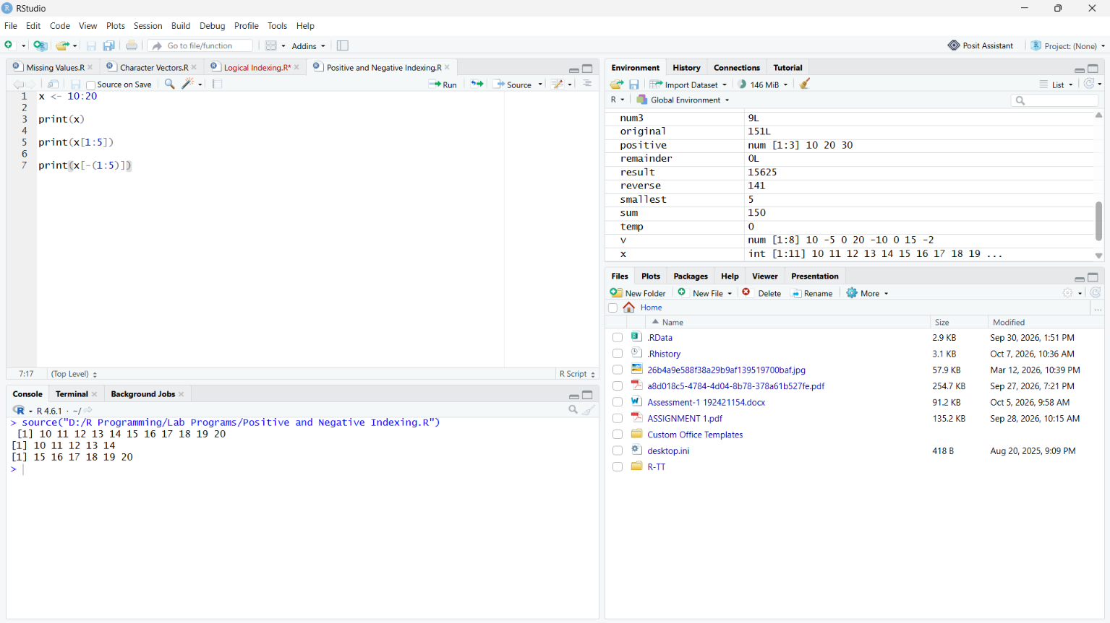

2.7.2.1 Selecting a single element
Aim: To select a particular element using its position.
Explanation: x[6] selects the sixth component of x.

R Code:
x <- c(10, 20, 30, 40, 50, 60, 70)
x[6]
Sample Console Output
[1] 60

2.7.2.2 Selecting a range of positions
Aim: To select the first ten elements using positive integer indexing.
Explanation: The expression 1:10 generates the index vector 1, 2, ..., 10.

R Code:
x <- 11:20
x[1:10]
Sample Console Output
[1] 11 12 13 14 15 16 17 18 19 20

2.7.2.3 Repeated positive indices
Aim: To demonstrate that positive indices may be repeated.
Explanation: Repeated indices cause the corresponding elements to be repeated in the result.

R Code:
x <- c("x", "y")
y <- x[c(1, 2, 2, 1)]
y
Sample Console Output
[1] "x" "y" "y" "x"

2.7.3 Negative integer index vectors
A negative integer index specifies the elements that should be excluded rather than selected. For example, x[-(1:5)] means that the first five elements are omitted.

2.7.3.1 Excluding the first five elements
Aim: To select all elements except the first five.
Explanation: The negative index -(1:5) tells R to omit positions 1 through 5.

R Code:
x <- 1:10
y <- x[-(1:5)]
y
Sample Console Output
[1] 6 7 8 9 10

2.7.4 Character index vectors
If an object has a names attribute, its elements can be selected using their character names. This can be easier to read than numeric positions.

2.7.4.1 Assigning names and selecting by name
Aim: To assign names to vector elements and select elements using character indices.
Explanation: The names() function assigns labels to vector positions. The character labels can then be used inside square brackets.

R Code:
fruit <- c(5, 10, 1, 20)
names(fruit) <- c("orange", "banana", "apple", "peach")
lunch <- fruit[c("apple", "orange")]
lunch
Sample Console Output
apple orange
1 5

2.7.5 Modifying subsets by indexed assignment
An indexed expression can appear on the left side of an assignment. In that case, only the selected elements are modified; the rest of the vector remains unchanged.

2.7.5.1 Replace missing values with zero
Aim: To replace all missing values in a vector with zero.
Explanation: The index x[is.na(x)] identifies only the positions containing NA. Assigning 0 to that indexed expression replaces those values.

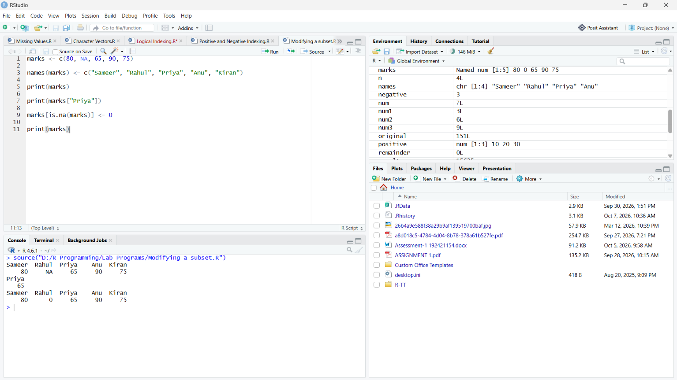

R Code:
x <- c(10, NA, 30, NA, 50)
x[is.na(x)] <- 0
x
Sample Console Output
[1] 10 0 30 0 50

2.7.5.2 Convert negative values to positive values
Aim: To replace every negative element by its positive counterpart.
Explanation: The index y < 0 selects negative values. The expression -y[y < 0] changes their signs.

R Code:
y <- c(10, -5, 20, -8, 30)
y[y < 0] <- -y[y < 0]
y
Sample Console Output
[1] 10 5 20 8 30

Integrated Practical — Sections 2.5 to 2.7
The following program combines missing-value handling, character vectors, paste(), logical indexing, positive indexing, negative indexing, named indexing, and subset modification in one execution.
# Missing values
marks <- c(80, 75, NA, 92, 68)
cat("Original marks:\n")
print(marks)
cat("\nMissing-value positions:\n")
print(is.na(marks))
clean_marks <- marks[!is.na(marks)]
cat("\nNon-missing marks:\n")
print(clean_marks)
# Character vector
students <- c("Asha", "Bala", "Charan", "Divya")
cat("\nStudents:\n")
print(students)
# paste()
labels <- paste("Student", 1:4, sep = "_")
cat("\nGenerated labels:\n")
print(labels)
# Positive indexing
cat("\nFirst two students:\n")
print(students[1:2])
# Negative indexing
cat("\nStudents except the first one:\n")
print(students[-1])
# Named indexing
scores <- c(80, 75, 92, 68)
names(scores) <- students
cat("\nScore of Charan:\n")
print(scores["Charan"])
# Replace missing values
marks[is.na(marks)] <- 0
cat("\nMarks after replacing NA with 0:\n")
print(marks)
Sample Console Output
Original marks:
[1] 80 75 NA 92 68
Missing-value positions:
[1] FALSE FALSE TRUE FALSE FALSE
Non-missing marks:
[1] 80 75 92 68
Students:
[1] "Asha" "Bala" "Charan" "Divya"
Generated labels:
[1] "Student_1" "Student_2" "Student_3" "Student_4"
First two students:
[1] "Asha" "Bala"
Students except the first one:
[1] "Bala" "Charan" "Divya"
Score of Charan:
Charan
92
Marks after replacing NA with 0:
[1] 80 75 0 92 68

Conclusion
Thus, the fundamental R operations covered in Sections 2.5 to 2.7 were studied and implemented. The programs demonstrate how R handles missing values and NaN, creates and combines character vectors, generates labels using paste(), selects vector elements using logical, positive, negative and character indices, and modifies selected subsets through indexed assignment.

